Change 1
Change input to STAS based on ‘Request Status’ and ‘Approval Status’.

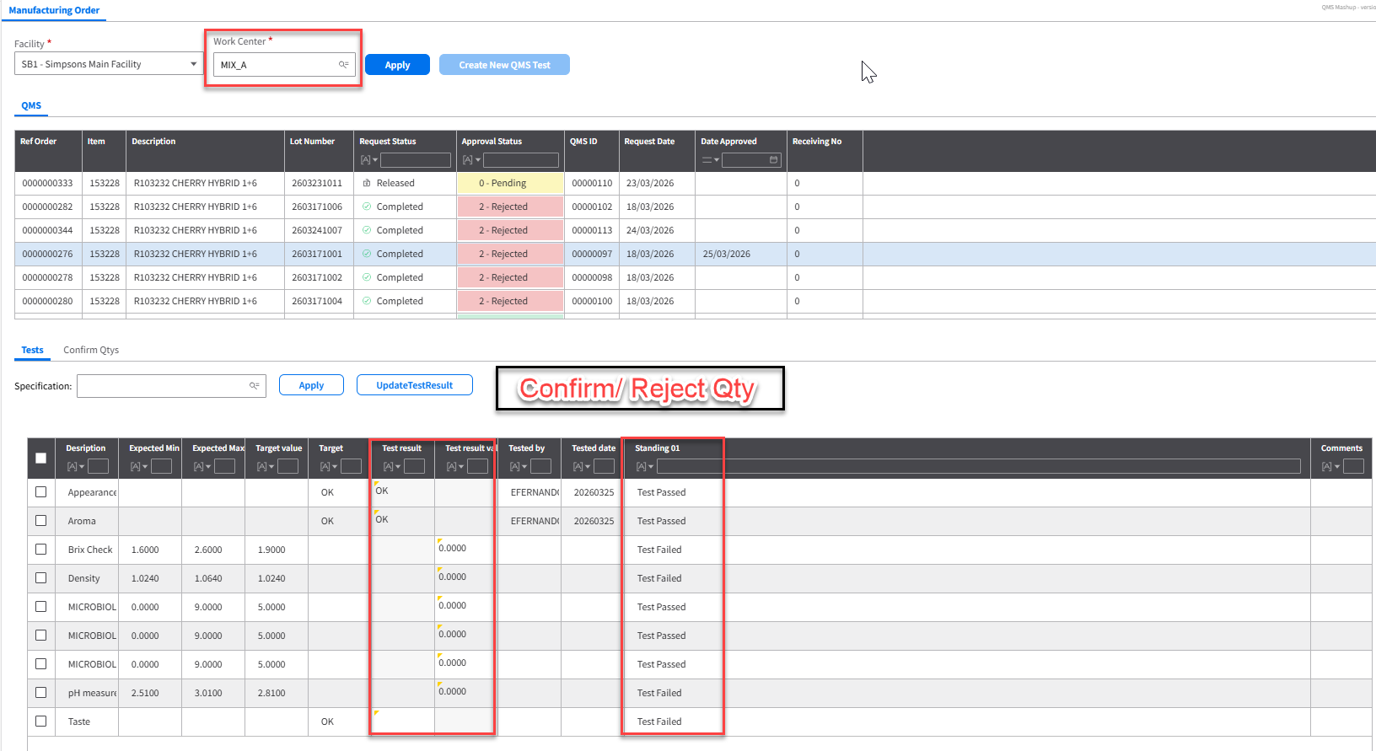
  - API: PMS130MI
  - Transaction: SetQIItmPutAway
Description | Field | Test Value | Retrieval Method
Item number | ITNO | 153228 | Item number against the record selected on the QMS tab
Lot number | BANO | 2602031021 | Lot number against the record selected on the QMS tab
Status – balance ID | STAS | 2 | Status Bal ID input will be based on ‘Request Status’ and ‘Approval Status’. If ‘Request Status’ is Completed AND ‘Approval Status’ is Approved, STAS needs to be 2. If ‘Request Status’ is Completed AND ‘Approval Status’ is Rejected, STAS needs to be 3.
Allocatable | ALOC | 1 | Hardcode to 1

